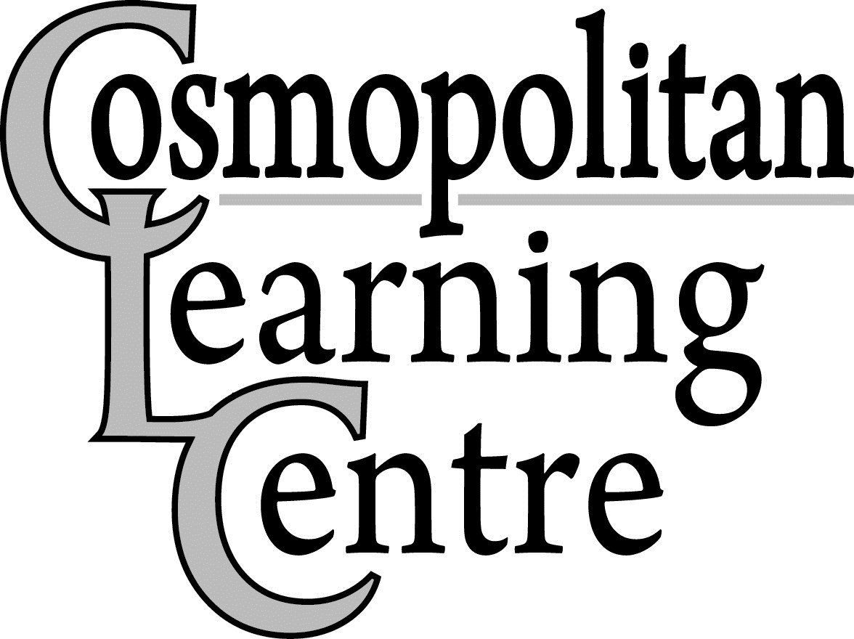
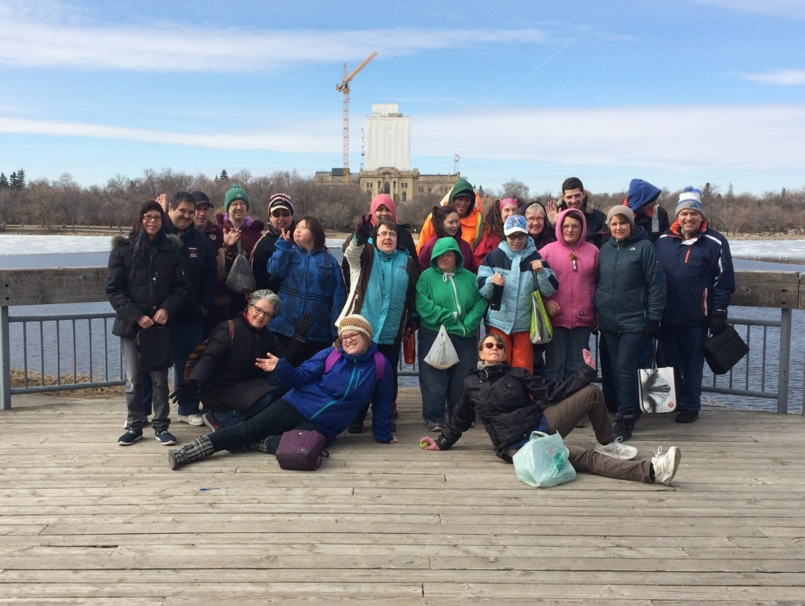

Planting Dreams
Growing Possibilities

2015 ~ 2016 Annual Report

Agenda

ITEM #1 ~ CALL MEETING TO ORDER

ITEM #2 ~ MINUTES OF THE ANNUAL GENERAL MEETING, JUNE 17, 2015

ITEM #3 ~ BUSINESS ARISING FROM THE MINUTES ITEM #4 ~ NEW BUSINESS & RESOLUTIONS
ITEM #5 ~ ELECTIONS

ITEM #6 ~ CHAIRMAN’S REPORT ITEM #7 ~ AUDITOR’S REPORT
ITEM #8 ~ ADMISSIONS & TRANSITION COMMITTEE REPORT ITEM #9 ~ PROGRAM REPORT
ITEM #10 ~ SARCAN REPORT

ITEM #11 ~ HUMAN RESOURCE REPORT

ITEM #12 ~ EXECUTIVE DIRECTOR’S REPORT

ITEM #13 ~ COMMUNITY CONNECTIONS PERFORMANCE

Performed by: Tasha Davey, Lorna Passmore, Becky Moore, Monica Death, Symone McCorkill, Jordana

Unsworth, Darren Vogt, David Wright and Ashley Hamel.

ITEM #14 ~ VIDEO PRESENTATION

Cosmopolitan Learning Centre 1 2015 ~ 2016 Annual Report

Minutes
Cosmopolitan Learning Centre Annual General Meeting Thursday June 17, 2015

Meeting called to order at 6:30 p.m.

Present

Amanda Davey  Linda Davey | Verna Howie  Arlene Hubick | Dwight Blomander  Nathan Hubick | Joan Reeh  Glen Berger
Bart Dixon | Carrie Fulucke | Jeannette Skibicki | Doloris Vicenzino
David Pinay | Terri Portras | Marcia Watson | Tasha Davey
Andrew Davey | Lynne Demeule | Angela Dobranski | Murelle Davis
Dennis Friesen | Adrienne McCorkill | Tracy Brassard | Amira Muller
Marj Phillips | Julie Anna McCorkill | Tracy Moore | Pat Watt
Brian Haswell | Karen McIvor | Trevor Gates | Joanne Wareing
Doug Measner | Albert Chervinski | Louis Toth | Tasha Davey
Jerry Baytaluke | Chris Zarember | Teena Tweed | Murelle Davis
Susan Measner | Corrina Kantymir | Becky Moore | Amira Muller
Christine Simle | Tyne Hallgrimson | Mindy Strom | Pat Watt
Mason Simle | Rick Hack | Ashley Carswell | Joe Kazeil
Ryan Kaytor | Laurie Adams | Ron Langelier | Chris McLeod
Sherry Matusko | Lucy Biliak | Fay Langeleir | Mert Moore
Andee Evans | Annette Deis | Symone McCorkill | Chris Dizy
Nora Copeman | Lorna Passmore | Ashley Deis | Marquerite Baier
Amanda Watson | Niomi Davis | Darlene Keen | Joanne Bevan
Cheryl Cameron | Harlow Laloudakis | Amanda Nordal | Shirley Bugg
Henry Baier | Marion Nestegard | Lindsay Measner | Belinda McCallum
Dennis Nestegard  Regrets: Rick Watson | Lorne Wirth | Voula Danakas | Karen Shepherd
Kevin Foley | Duncan Louttit | Tina Allen | Connie Lang-Schuette

Cosmopolitan Learning Centre 2 2015 ~ 2016 Annual Report

Supporters of the Centre 2015 ~ 2016

Regina Capital Cosmo Club | Regina Vogt | Brian & Millie Zurowski
Regina Cosmopolitan Club | J.R. Lane | Joanne & Peter Tyerman
Able Busing Corp. | Simone Lepage | Fidelity Investments
Wascana Cosmo Couples | Roseann Kohne | Darren & Terri Lynn Singer
Chris & Florence Dizy | Jacquelina Scott | Highway Agencies
Regina Soffit & Eave | Dale O’Neil | Dan & Barb Cameron
Signature Print It Centre | Mark Geiger | Victoria East Denture Clinic
Victoria Tramer | Laurie Artiss | Ann & Robert Meyer
Voula Danakas | Capital Cabs | Regina Food Bank

Thank you for your continuing support!

Admissions & Transition Committee Report

The Admissions and Transition Committee is comprised of members from Community Living Service Delivery, Cosmopolitan Learning Centre Board of Directors, the Executive Director of the Cosmopolitan Learning Centre, and the Program Manager of the Cosmopolitan Learning Centre.

The Committee reviews existing participant’s status with the centre and reviews new applications for service. New applications are currently being placed on a waitlist for service. The waitlist for service is currently 40
applications.

CCoossmmooppoolliittaann LLeeaarrnniinngg CCeennttrree 3
22001155 ~~ 22001166
AAnnnnuuaall RReeppoorrtt

Minutes

Item #1: Call Meeting to Order

President Chris Dizy called the 2014~2015 annual general meeting to order at 6:30pm.

Item #2: Minutes of the last Annual General Meeting from June 17, 2014

Motion: To accept the minutes of the June 17, 2014 annual general meeting. Moved by Mr. Joe Kazeil, seconded by Mr. Rick Hack. Carried

Item #3: New Business Arising out of the Minutes

No business arising from the minutes.

Item #4: New Business and Resolutions

No new business.

Item #5: Elections

Dwight Blomander said that he is handling the nominations for this year. Dwight is glad to say that there is a full slate of officers for the upcoming year. Dwight asked if there are any nominations from the floor. No additional nominations were brought forward as a result.

Motion: To have nominations seized as there are no additional nominations. Seconded by Brian Haswell.
Carried.

Dwight announced the 2015-2016 Board of Directors for the Cosmopolitan Learning Centre. Tina Allen, Dwight Blomander, Voula Danakas, Karen Shepherd, Joe Kazeil, Lorne Wirth, Kevin Foley, Brian Haswell, Dennis Friesen, Rick Hack, Rick Watson, Chris Dizy,

Motion: To re-appoint Crowe-MacKay as Auditor for 2015-2016 fiscal year. Seconded by Rick Hack. Carried

Item #6: Chairman’s Report

President Chris Dizy presented his report as written. Chris thanked the staff for their enthusiasm, creativity and hard work.

Item #7: Auditor’s Report

Glen Berger from Crowe MacKay presented the auditor’s report. Glen said that many years ago he was involved with Cosmo and since Andre has retired he has the opportunity to become involved once again. Glen said that he is pleased that Crowe MacKay is able to continue as auditor for the upcoming year. Glen provided a few finan- cial highlights and said that he is pleased to offer an unqualified opinion which means the audit is done fairly and in accordance with accounting principles. Glen said that there were no concerns with the audit which means that systems within the organization are working well. Glen said that the organization’s board and management is reliable to be financially responsible and have a good hold on operational functions. He noted that there was an increase in revenues with grants, Sarcan, etc. Glen also noted that there is a surplus for the year of $138,000.00 and although this sounds like a large sum of funds, an organization such as Cosmo requires a large amount of funds to operate.

Motion: To accept the Audit Report as circulated. Moved by Glen Berger, seconded by Joe Kazeil. Carried.

Cosmopolitan Learning Centre 4 2015 ~ 2016 Annual Report

Item # 8: Program Report
Program Manager Bart Dixon presented his report as per report book. Bart spoke of the many programs going on at the centre from Choir and Drama Club, Entertainment Club for more centre-wide activities, to supporting individuals at their jobs. He noted that Cosmo has a wide range of programs that the centre offers. Individuals may begin in our Supported Employment program and may move on to independent employment which would be a goal for those individuals. Bart noted that it’s about building skills, such as the skills to perform at tonight’s event. The centre is always growing and recently there was an individual who applied at our centre and also had the option of going to two other different agencies. That individual chose to come to Cosmo and that speaks volumes as to the work we are doing – thank you to Jeannette for her great employment program where this individual chose to attend. Bart thanked the staff and participants for another great year.

Item #9: Admissions and Review Committee Report
Report presented as per report book.

Item #10: Sarcan Report
Report presented as per report book.

Item #11: Human Resource Report
Report presented as per report book.

Item #12: Executive Director’s Report
In the absence of Connie Lang Schuette, Executive Director, her report was presented by Terri Portras, Program Coordinator. Presented as per report book. The participants are always so excited to show up to work and have their day begin. The Cosmopolitan Clubs continue to be a great support for the centre and we thank them once again. The funds they donate help to provide many great opportunities for those who attend the centre. Congratulations to Cosmo on 45 years of service. Thank you to all the staff and leadership team as well as to Gord Lennox who is retiring after 18 years of service. Special thanks to the board of directors for your commitment and knowledge that you bring to the centre. Thank you to Chris Dizy for the past two years as Chairman and special thank you to all the participants!

Item #13: Community Connections Performance
The Connections area performed for the attendees of the annual general meeting.

Item #14: Video Presentation
A video presentation was presented for the attendees of the annual general meeting.

Motion to accept the 2014-2015 Annual General Meeting Report booklet as circulated. Moved by Chris Dizy, seconded by Dennis Friesen. Carried.

Cosmopolitan Learning Centre 5 2015 ~ 2016 Annual Report

Board Chairman Report

I would like to take this opportunity to recognize and thank the staff and management of the Cosmopolitan Learning Centre for their hard work that contributed another successful year of operation. Their dedication to the participants of Cosmo Learning Centre and this sector as a whole, are very much appreciated by the Board of Directors and the people of this community.

The last year has presented some challenges to the Board, management team and staff. However, it was nothing that these capable people couldn’t handle.

I would also like to take this opportunity to thank four Board members, who are leaving the Board, for their service to the Cosmo Learning Centre. All four are examples of the kind of people that make Saskatchewan a great place to live. They are Voula Danakas, Joe Kazeil , Chris Dizy and Kevin Foley. Voula and Joe are two Board members who have contributed many, many years of dedicated service to the Cosmo Learning Centre. Chris is another long time Board member. His knowledge and advice over the years had served the Board and Cosmo Learning Center well. Voula, Joe and Chris have played a significant role in making Cosmo Learning Centre the great success it is today. Their contributions are very much appreciated by their fellow Board members.

The coming year will hold new challenges for the Board, management and staff. We will be starting a new program to better serve our participants and the community. Connie will have more details on that.

I would also like to recognize and express the sincere appreciation of the Board of Directors for the long standing support Cosmo Learning Centre has received from the Cosmopolitan Clubs of Regina. Their ongoing support has made a tremendous difference to the participants’ wellbeing and daily enjoyment. Without the support of these very generous clubs our participants would miss out on many of the “extras” they enjoy at Cosmo Learning Centre. Thank you very much!

Thank you to all of the Board, management and staff of Cosmo Learning Centre. It has been an honour to work with you once again this past year

Brian Haswell
Board President
——————————————————————————————————————————————————

Board Members 2014 ~ 2015

Brian Haswell ~ President | Rick Watson ~ Vice President | Lorne Wirth ~ Treasurer
Chris Dizy ~ Past President | Dennis Friesen ~ Director | Voula Danakas ~ Director
Kevin Foley ~ Director | Karen Shepherd ~ Director | Duncan Louttit ~ Director
Joe Kazeil ~ Director | Dwight Blomander ~ Director | Tina Allen ~ Director
Rick Hack ~ Director | Connie Lang-Schuette ~ Secretary

Board Members Resigning

Joe Kazeil Chris Dizy Voula Danakas Kevin Foley

Nominations

Perry Kirton Catherine Duczek

Cosmopolitan Learning Centre 6 2015 ~ 2016 Annual Report

Program Report

This past year has proven to be another big year at the centre. In the Program area the Centre strives each day to enrich the lives of the participants that have chosen to attend our program. We strive to create a community of acceptance and inclusion. The Centre uses a person centred approach to assist participants, whether its learning about plants, painting a picture, enjoying music therapy or going to work for the first time and receiving a pay cheque. Every day brings excitement and a learning opportunity.

The social committee is busy group, ensuring no special occasion goes unrecognized. The participants at the centre always enjoy the special lunches the social committee prepares for Christmas, Easter, Thanksgiving and the summer barbeque.

The entertainment club definitely keeps everyone entertained. Staff and Participants enjoyed our rendition of Fear Factor, The Price is Right or Family Feud. This year the committee held a winter carnival as well as a summer carnival.

On the quiet side we have the snoozelen room, therapy spas, reading club, art programs, and gardening. All the activities keep the participants engaged and coming back each day.

If things get a little quiet one only needs to attend the weekly laughter yoga session for a pick me up. Pet therapy and music appreciation get us moving and shaking. The Centre has groups that are for women and men. The sparkle group makes sure everyone is looking their best with hair, makeup and nails. The men’s club gets it’s fix of sporting events and sports news. The Roughriders have been providing lots of discussion for the group.

Each week the participants go out and take part in their community socializing with new friends at the fieldhouse, Wascana Park, Museums, Malls and various businesses. The participants often know more people in the community then the staff. Community members ask where the participants are when we are away.

For the participants in our Community Services program it has been a year of adjustment with the relocation of the program to the main Cosmopolitan Learning Centre happening one year ago everyone is getting settled in. The Community Services program added some new job placements that ensure we have a strong presence in the community workforce.

The new Broadway location opened its doors in February starting with 18 participants. The group has not taken long to get back into the community by getting involved with a number of community groups. The participants are going to try its hand at planting a community garden this year. We have already connected with the other tenants of the building and they have expressed interest in joining our staff and participants for their morning exercise.

For those parents and caregivers that were able to attend an event at the center we hope the experience provided you the same happiness we experience each day.

One page to write about the programs at the Cosmo cannot do justice to all the events, activities, work placements, care, compassion, and growth that occurs within one year at the Cosmopolitan Learning Centre. The staff and participants go home each day knowing they did all they could to the best of their abilities to enhance their lives and the lives of those around them. Thank you to all the participants that have chosen the Cosmopolitan Learning Centre for their day program needs.

Currently 230 participants are being supported by the Cosmopolitan Learning Centre. This past year saw 16 new participants starting at the centre. The Centre is planning on increasing its capacity over the next year by 10 participants

Cosmopolitan Learning Centre 7 2015 ~ 2016 Annual Report

Sarcan Report

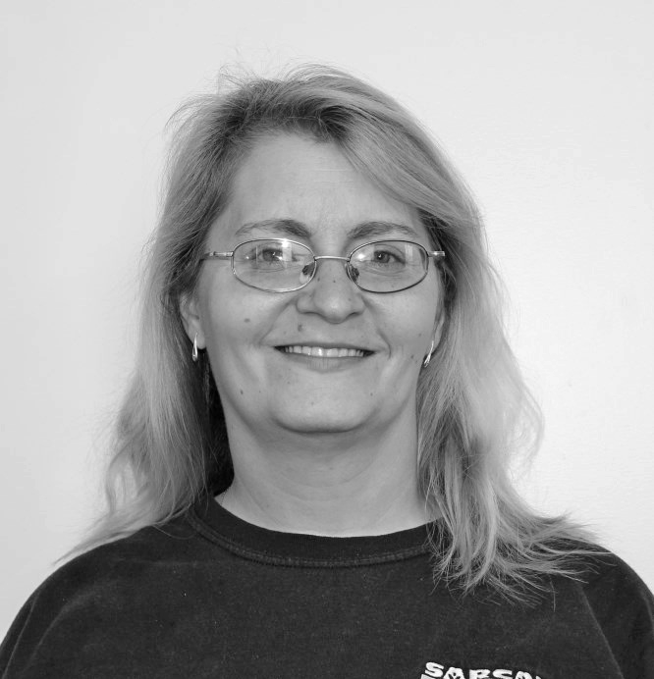
Wanita Carswell
Supervisor
Greetings everyone from the Victoria Ave East Sarcan. We’ve MOVED! We have relocated into a new depot that is bigger and a lot brighter. Come check it out only mere feet from the previous location,
2636 Victoria Ave E (same parking lot as Giant Tiger). We also have a new program with Sarcan, Drop N’Go. Drop N’Go was established for the customer who doesn’t have time to stand in line. It is very easy; all you need is an email account. You can sign up in any depot or online at www.sarcan.ca and you have the option of either Paypal or cheque for payment.

The 2015/16 fiscal year was a very good year. We acquired 18.1 million containers, consistent with the 2014/2015 year. Sarcan hit a new record of 7 billion containers that have been recycled since we started in 1988. If you recall, we hit the 6 billion mark in 2013 at the Rochdale location.

We are still the number one depot in the city for recycling electronics

and paint. Customers brought us 380,000 lbs. of their outdated or broken electronics and 20,000 liters of paint. With the new building and more room , we can accommodate it much better.

Congratulations goes out to Wayne Main and Sharon Jestin who celebrated their 5 year anniversary and Vincent Hori celebrated his 15th year with Sarcan. Congratulations to them!! Calvin Donald who is one of my best employees has gone on to better things, retirement; he started a new chapter in his life at Cosmo. Seeing Calvin every day was a blessing, he always had a smile and loved to dance with me or just himself in the back. It sure has been an adjustment not having him here. We miss him and wish him the best in the future.

Now with summer around the corner everything is looking good, new depot, some new staff, and the new Drop
N’Go and hopefully some excellent weather.

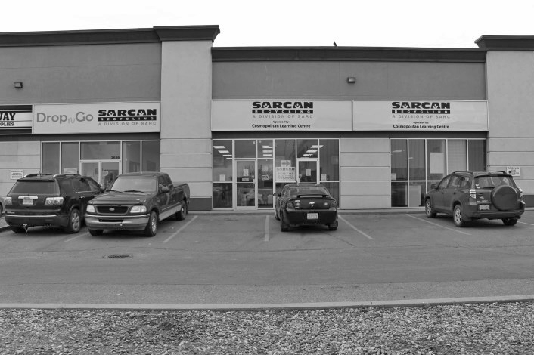
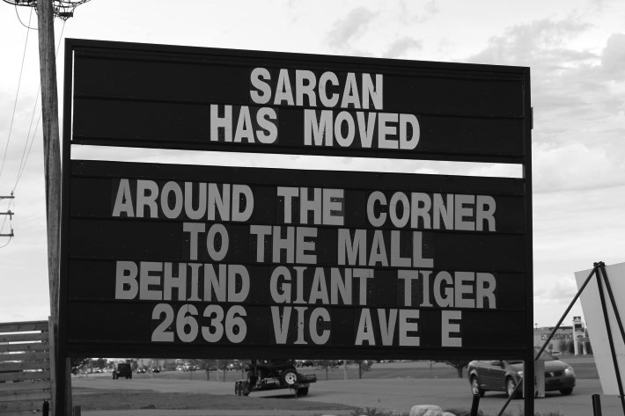
Have a safe and happy summer!!

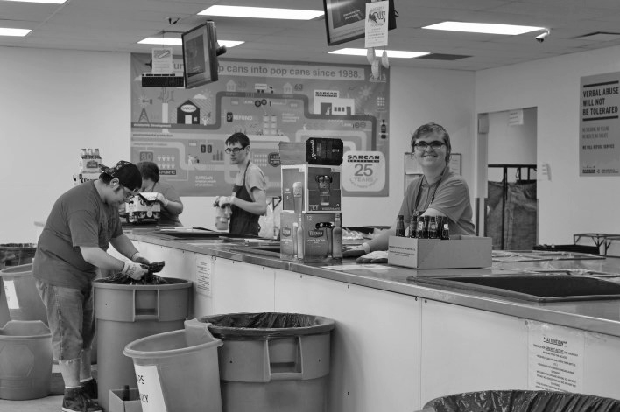
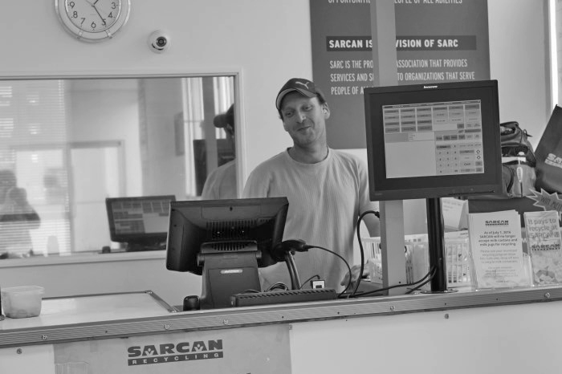
Cosmopolitan Learning Centre 8 2015 ~ 2016 Annual Report

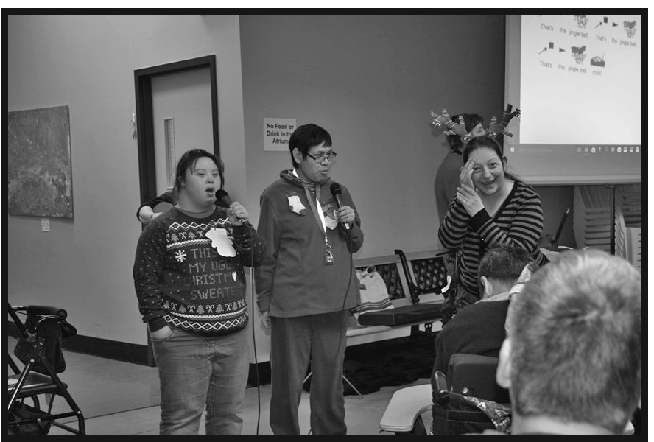
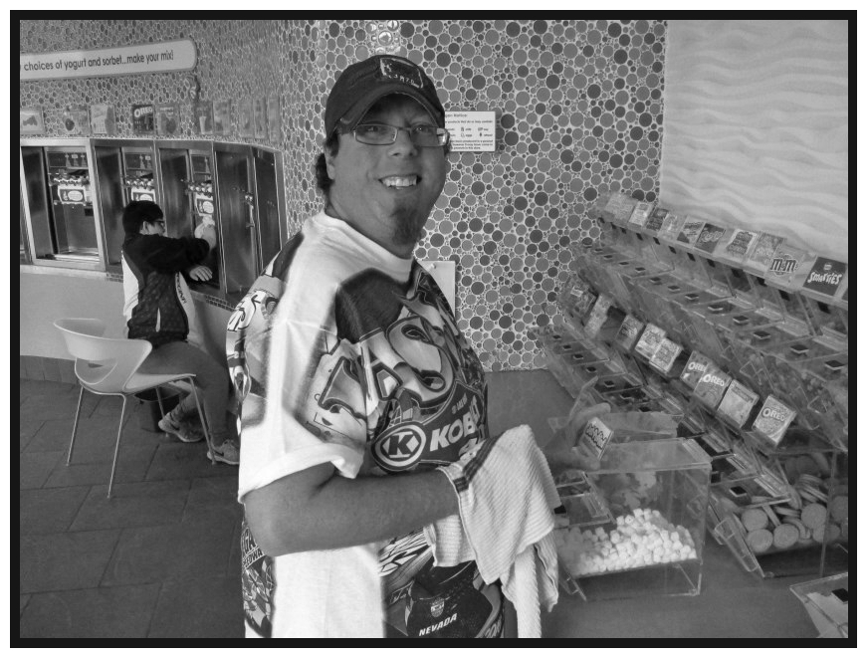
Cosmo at work and at play

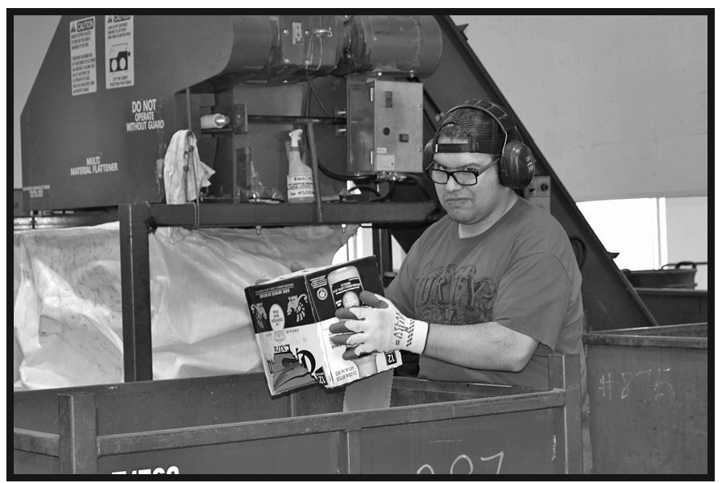

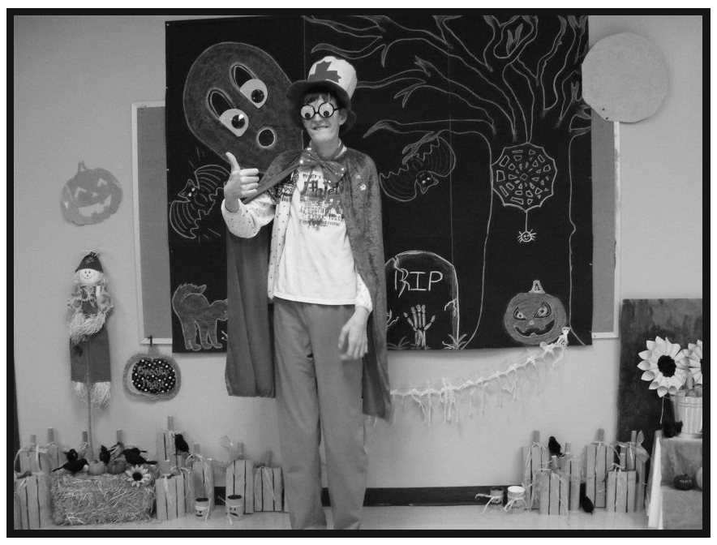

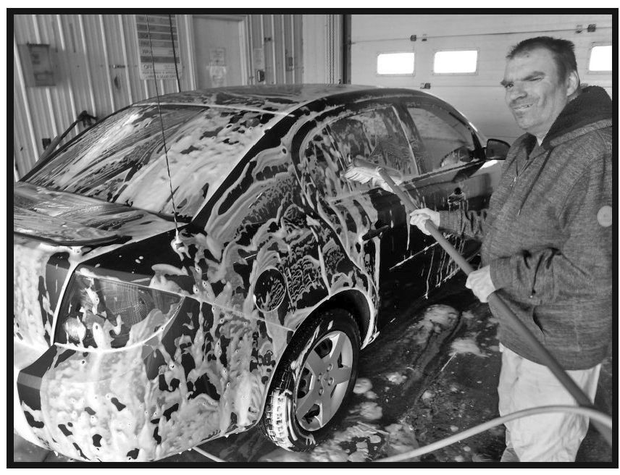

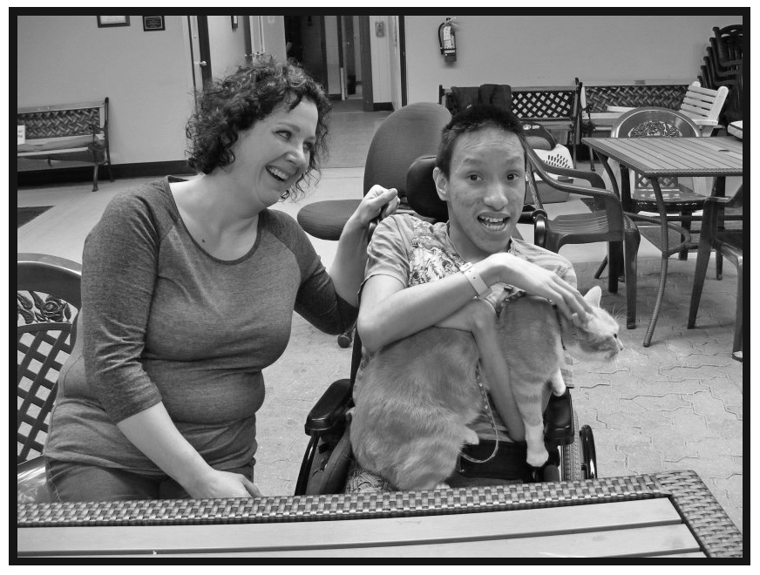
Cosmopolitan Learning Centre 9 2015 ~ 2016 Annual Report

Human Resource Report

The Centre has had another very busy year.

Due to an expansion of service to a new Broadway Avenue location, four more employee team members were able to become part of the team. This expansion was a big change for both Participants and Employees. All of those team members did a fantastic job of settling in to the new space. All the best to those Participants and Employees! With the expansion of service, we will be welcoming a new Assistant Program Coordinator to the leadership team in 2016.

The Organization takes pride in the variety of professional development opportunities provided to its Employees. Aside from the core trainings offered on an ongoing basis, Employees were able to participate in a seminar through M-Powered Planning about how to create inclusive experiences and foster a sense of community with the individuals attending the Centre. In addition, congratulations to the April 2016 Basic Skills Training graduates. These training opportunities support the Organization to ensure that Employees gain as much knowledge as possible, so that the Participants receive services of the highest quality.

Celebrating Employees continues to be an important part of the Organization. A pancake breakfast was held in February 2015, adding a team building element to the employee development opportunities. In the summer, a BBQ occurred again for all Employees and Participants to celebrate the upcoming summer break. An Employee BBQ was planned and prepared by the Employees on their last day of work before summer. Everyone seems to enjoy these events to create connections and foster a collaborative, positive team environment. Employees also enjoy the December’s “gift a day” draw. In December, the Organization had the opportunity to thank each Employee for their dedication with a gift card and a Christmas luncheon. This celebration allows us to share a meal together, celebrate the upcoming holiday and to connect as a larger team. Everyone seems to enjoy this time! In addition, selected Employees were presented with a small thank you gift, as these Employees continue to go over and above expectations.

Congratulations to Fred Brooks, Gord Lennox and Vincent Hori (March 2016). These individuals have retired. We wish them all the best in their retirement and thank them for their dedication to the Organization.

Participants and Employees were able to purchase a logoed Cosmo jacket this past spring. Thank you in advance for all of those who are getting a jacket. Wear it with pride!

Congratulations to everyone who received their service awards this past year. Well done! Thank you to all of the Participants for their hard work and enthusiasm and to all of the Employees for their dedication and commitment to the Organization.

Cosmopolitan Learning Centre Service Awards 2015

We would like to extend congratulations to the following Staff and Participants for their long term service with the
Organization for 2015.

5 Years of Service:

Participants—Sherry Nechvatal, Michelle Shepherd, David Wright, James Yule,

Employee—Don Laliberte, Abdul Mohamed, Richard Moreau, Belinda McCallum, Ann Schubert, Linda Barabash,

Cosmopolitan Learning Centre 10 2015 ~ 2016 Annual Report

10 Years of Service:
Participant—Bonnie Goodwill, Nathan Hubick, Jarred MacDonald, Jordan Steinhubl. Employee—Amanda Parisien.

15 Years of Service:
Participant —Gerrit Barnard, Jennifer Borschowa, Fabian Douglas, Nathan Pinay, Employee —Shirley Bugg, Vincent Hori.

20 Years of Service:
Participant —Jarret Aston, Amber Johnson, Bruce Kaufmann, Becky Moore, David Psiurski, Jayson Wessner. Employee— Jeannette Skibicki.

25 Years of Service:

Participant—Paige Carney, Morganna Foord, Jane Anne Griffin, Brent Hoffmann, Akio Kocks, Donald Novak, Stephanie Pelly.

30 Years of Service:

Participant—Gwen Geigle, Janie Hazen, Grant Schaffer, Graham Watson.

35 Years of Service:

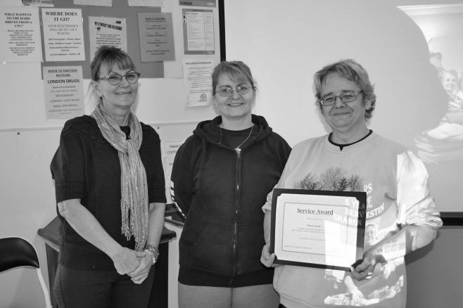
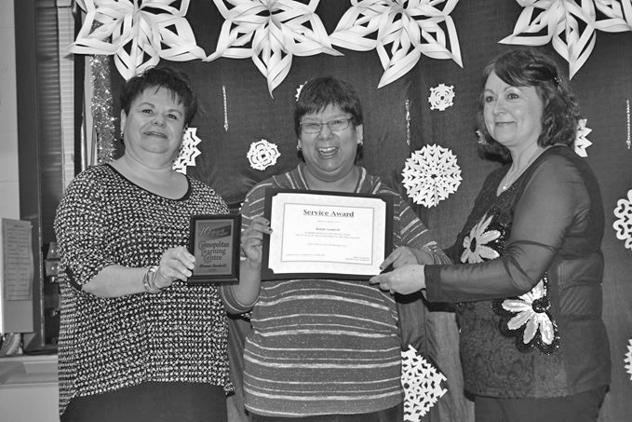
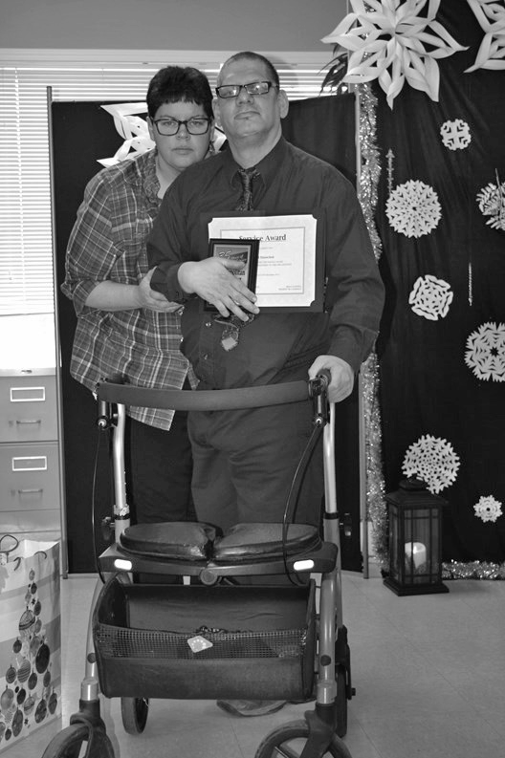
Participant—Robert Paraschuk.

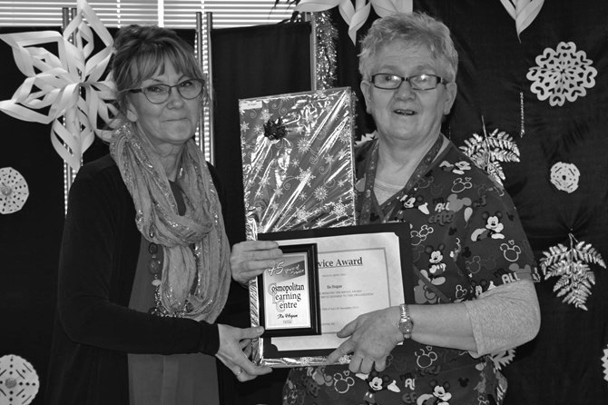
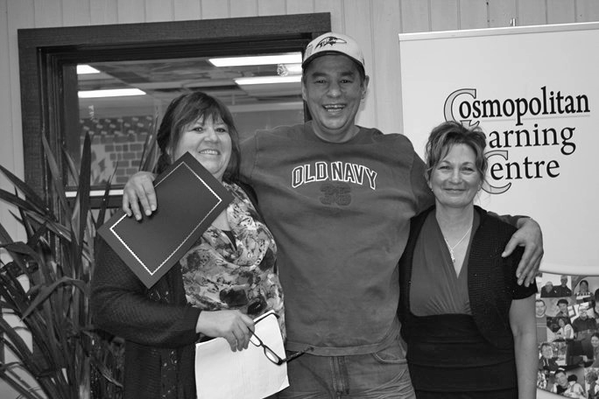
Cosmopolitan Learning Centre 11 2015 ~ 2016 Annual Report

These are a few of our favorite things!

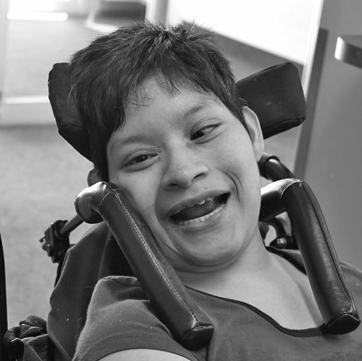
Kristy Yoc ~ Life Skills I

Kristy has been at Cosmo for 4 1/2 years. Kristy has the most infectious laugh. You can always hear a scream of joy when she comes in first thing in the morning, when it’s time for her to swim or to go on an outing. We could not imagine LS1 without her smile.

Jarret Aston ~ Life Skills II

Jarret has recently celebrated his 20th year at Cosmo. He loves to unload the dishwasher and go on outings. He has a contagious laugh and is always smiling. Jarret loves laughter yoga and music therapy.

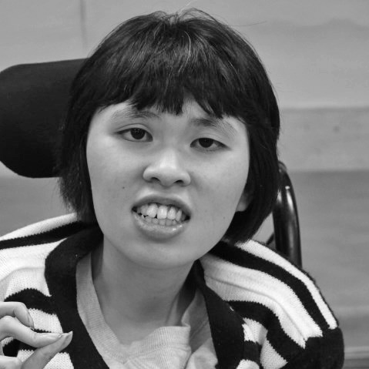
Jennifer Tran~ Life Skills III

Jennifer is an awesome addition to the LS3 room. Her contagious laugh lights up everyone’s spirits. She likes to help keep the room running in an orderly fashion, helping keep people ‘in line’. Thank you Jennifer for bringing your vibrant personality to Cosmo, we look forward to many more laughs with you.

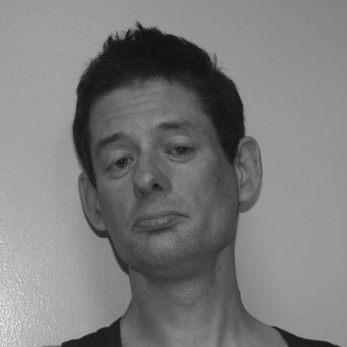
Kenny Ehrmantraut ~ Life Skills IV

Kenny is a very helpful and outgoing addition to LS4. Kenny enjoys socializing with his peers and friends. On a day to day basis he is always willing to lend a hand to someone in need or a shoulder to cry on when someone is upset. Kenny is a very laid back guy, but enjoys being active, he likes to walk around and use his fidget (ex. Kinder Surprise). We enjoy his sense of humour and welcome him to LS4.

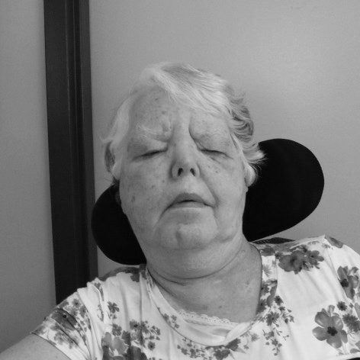
Mary Scott ~ Seniors

Mary is quite new to Cosmo and attends two days a week. Mary loves to listen to music and sing. She’s enjoying laughter yoga and reading club. Mary is always willing to try anything at least once. Mary is fitting in so well at Cosmo. She would love to attend five days
a week. Welcome Mary to the Cosmopolitan Learning Centre.

Cosmopolitan Learning Centre 12 2015 ~ 2016 Annual Report

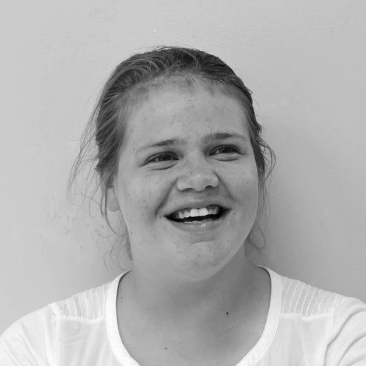
Tonya Unwin ~ Community

Tonya is new to the Community room. She loves to swim, read magazines, colour and spend time out in the community. Her energy and enthusiasm are infectious. The staff look forward to seeing her awesome smile every day!

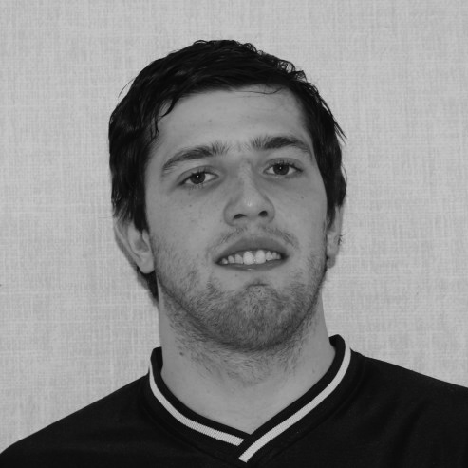
Michael Galgan ~ Community Connections

I like coming here because it is positive. I like the staff. I like going for walks and the lunch program. I like Ashley and Lisa and I like going on cookie sales. My favorite thing so far was the Dairy Farm tour.

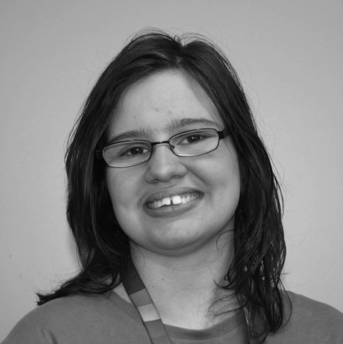
Michelle Dupuis ~ Connections

Michelle is a very pleasant and social loving lady. She always has a smile and is always willing and ready to help anyone. She is a very hard worker and takes pride in what she does. We are all very happy to have Michelle join our Connections team. Welcome Michelle!

Angeline Redman ~ Community Services

Angeline joined the Cosmopolitan Community Services group in February of 2015. Once she overcame her shyness she has made a lot of new friends. She says she loves working at her different jobs and most of all getting a pay check to support her dog and her outings.

Each person is like a butterfly in the wind. Some can fly higher than others, But each one flies the best it can. Why compare one against the other? Each one is different.
Each one is special.
Each one is beautiful.

Cosmopolitan Learning Centre 13 2015 ~ 2016 Annual Report

Executive Director Report

Another year has passed so quickly at the Learning Centre. As the saying goes, time flies when you’re having fun!

The Cosmopolitan Learning Center in partnership with CLSD has taken on another expansion. We have welcomed a group of individuals to take part in our new Community Connections location on Broadway Avenue. We were up and running on March 1st into a temporary small space and May 1st into a larger space. Both at 1440 Broadway Ave. We share this location with other Businesses and have enjoyed making connections with the other Leasers in the building. This new location is a busy place focusing on volunteerism and recreation in the community.

Participant growth and development is our focus throughout the Centre. We have many different options from employment, to volunteerism to recreation. Therefore, the participants can choose what they would like to do with their day. This is accomplished through the Person Centred Planning process. Our new location just adds one more option.

The Center continues to look at our emerging needs from the community which includes graduates from the school system or others who may just want a change in how they spend their days. We plan to offer day program to at least 10 more individuals over the next few months.

As the Center continues to grow so does our number of employees. Professional development is always a priority. We run 5-6 Professional Development days where the focus is to keep our staff current in past trainings and offer many other new trainings throughout each year.

Maintaining our building is a very important part of our annual planning process. We take on most maintenance and building enhancements during our 2 week closure each year. Summer of 2015 we replaced cupboards and counter tops, touch up paint throughout, as well as wall board to protect hallways. In the summer of 2016 we plan to repair a portion of our roof, re-pave the front parking lot, and replace a few more countertops as well as the annual carpet cleaning, floor stripping and waxing.

As a community based program, transporting our participants to and from the Center as well as getting individuals to their jobs, volunteer placements and recreation, becomes a very big part of our planning process; both financially as well as functionally. The transportation of individuals to and from the Center will go out for an RFP for the next fiscal year.

Our Sarcan Depot has moved into a new location. The new location is a larger depot to ensure we can serve the Extra Large Depot needs. We said goodbye to one of our long term staff, Vince Hori as he ventures into retirement. Special thanks to all of our depot staff. Great job!

The Center entered into a review process with OH&S and WCB to improve the Safety of our staff and participants, and in turn decrease our WCB claims. Our OH&S committee began meeting monthly to review “near misses” as well as in depth discussions around how to avoid injuries. With this our WCB claims have decreased and overall we have become a safer workplace.

The fundraising for the Learning Center that is taken on by the Cosmo Clubs continues to be the reason we can do so many extras for the men and women taking part in our program. Whether it be booking entertainment, having a BBQ celebration, purchasing a new AED machine or a new adjustable change mat. The fundraising efforts of the Cosmo Clubs provides us the flexibility to make independent decisions around various Center needs.

I would like to give a farewell and very special thank you to our four board members who are leaving this year. Voula
Danakas, Chris Dizy, Kevin Foley, and Joe Kazeil. We truly appreciate your commitment to our organization.

I would also like to welcome our two new board members – Kathy Duczek and Perry Kirton. We look forward to working with you.

I would like to thank those board members who have decided to serve for yet another year. It is always a pleasure to work with such knowledgeable, dedicated people.

To the staff at the centre, thank you for your hard work and dedication. You “make it happen” at the centre every day.

To the participants, thank you! As we grow and move into the future, it is our program participant’s energy and enthusiasm that guide us in our organizational decisions every year.

Cosmopolitan Learning Centre 14 2015 ~ 2016 Annual Report

Special Days at Cosmo!

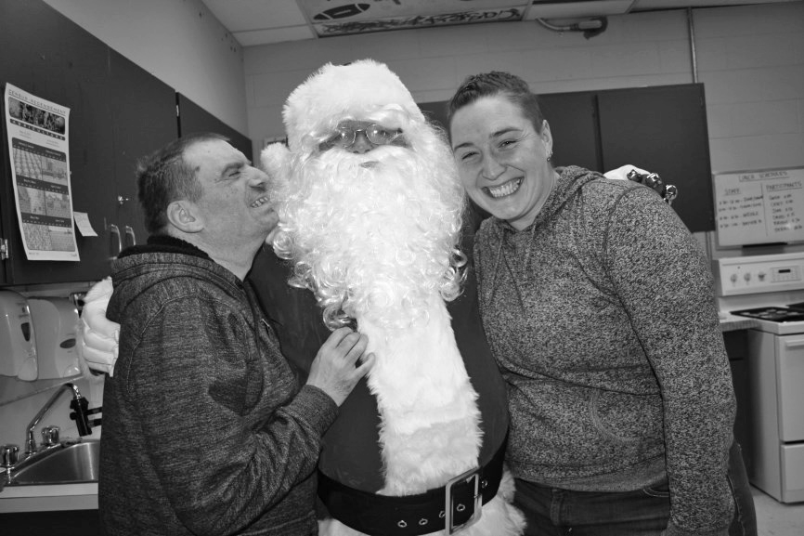
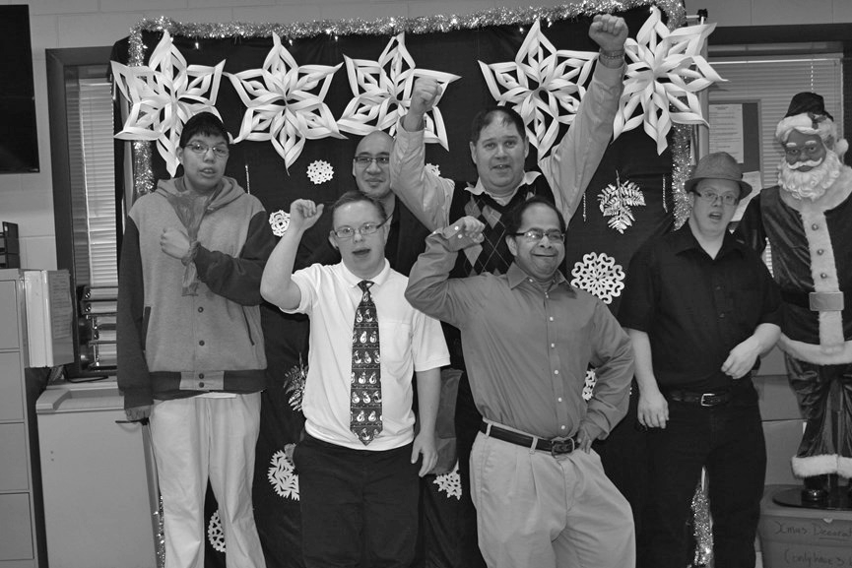
Satellite Christmas Party A Visit from Santa

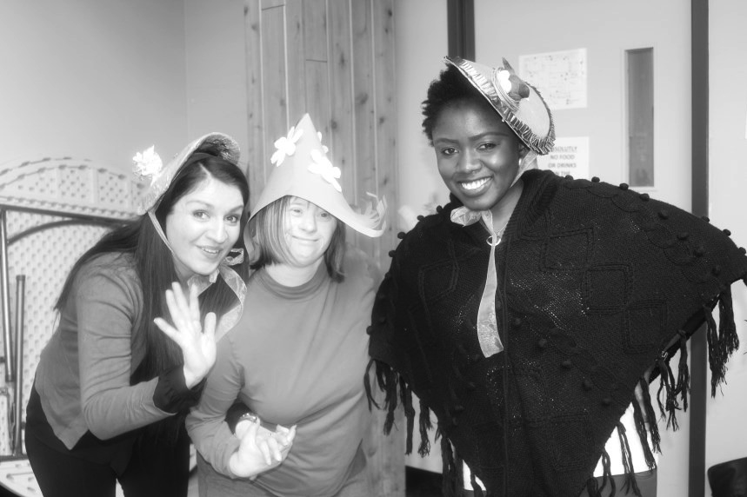
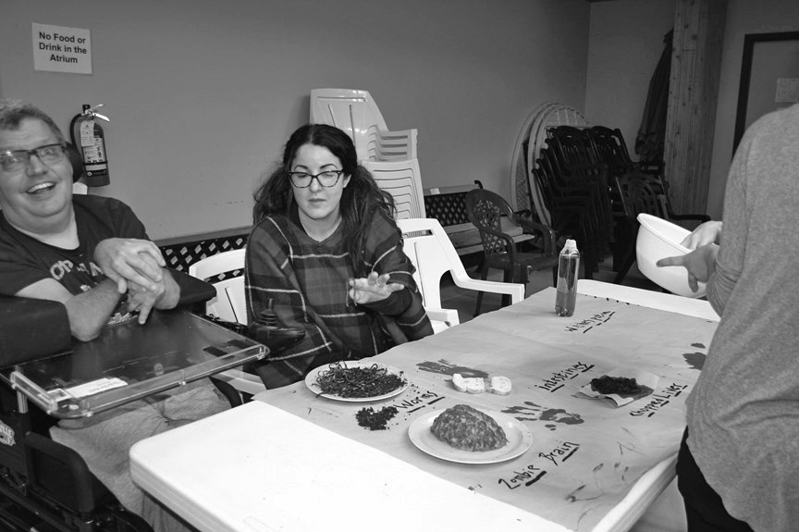
Easter Parade Cosmo Fear Factor

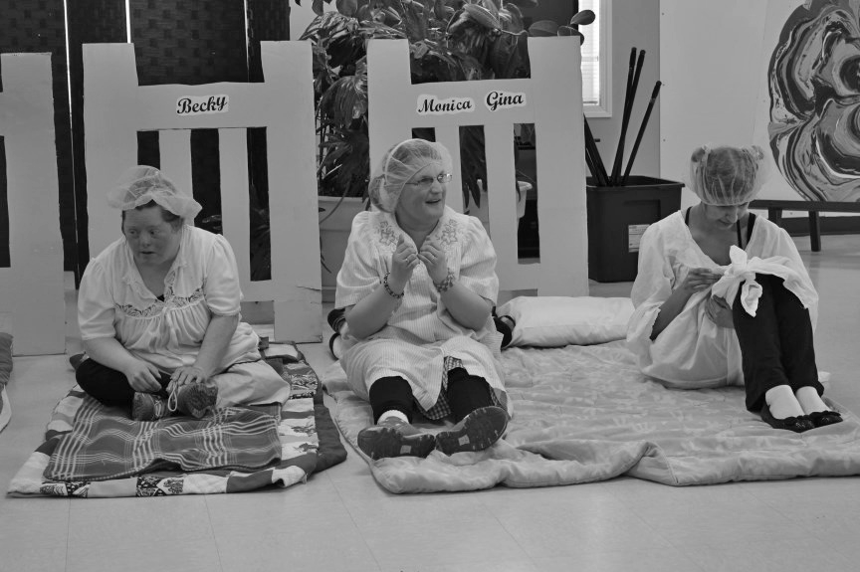
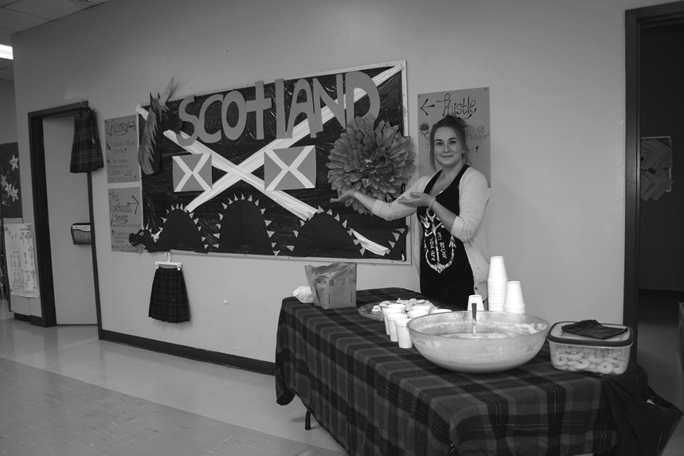
Annie Mosaic

Cosmopolitan Learning Centre 15 2015 ~ 2016 Annual Report

Staff Training and Special Events!

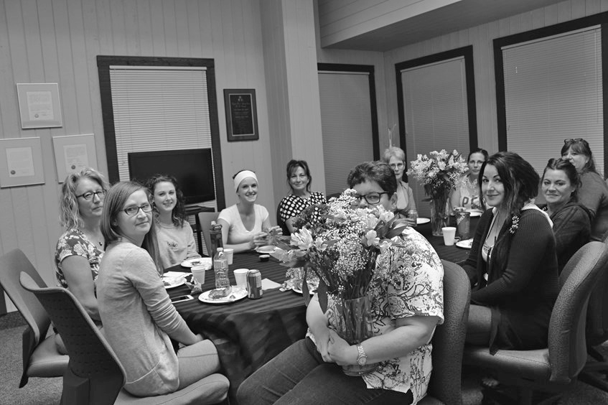
Fire Extinguisher Training Social Committee Thank You Luncheon

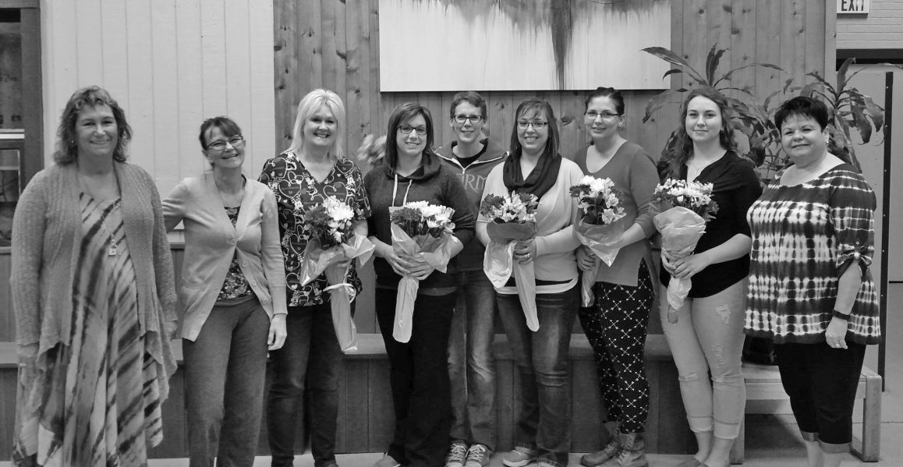
B.S.T. Graduating Class

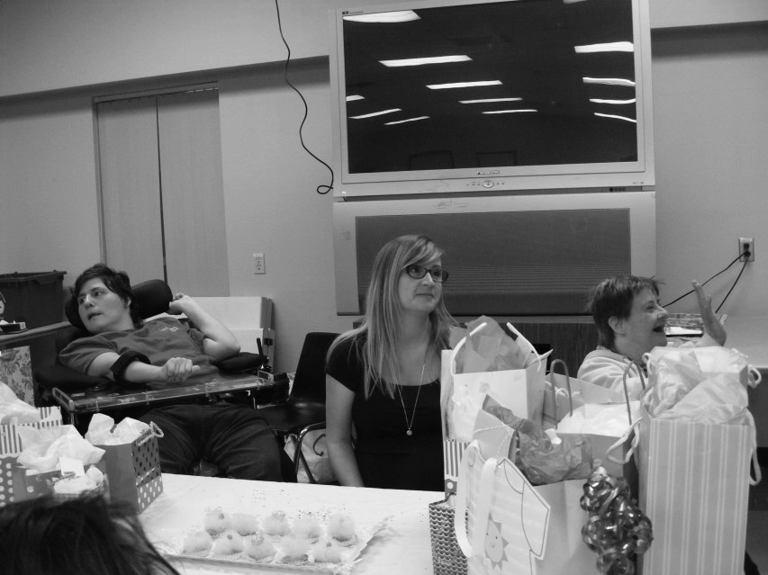
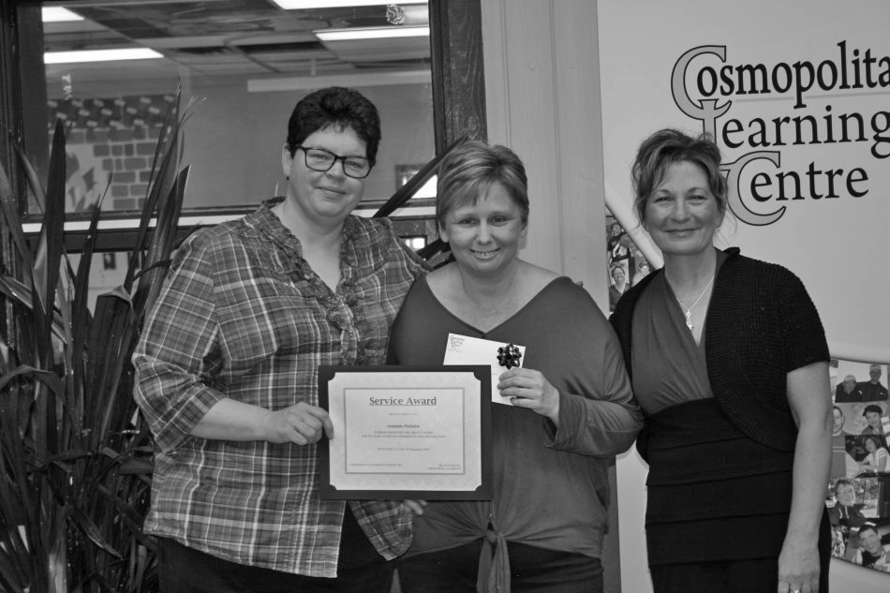
Baby Shower Staff Service Awards and Christmas Luncheon

Cosmopolitan Learning Centre 16 2015 ~ 2016 Annual Report

In Memoriam

Don Roy Blair ~January 3, 1954~September 2, 2015

Don was a very special part of The Cosmopolitan Learning Centre for 23 years. He was a loyal person who would do anything for his friends. In Don’s early years he spent a lot of time on his artwork and participating in many activities throughout the centre. He loved his outings and socializing with both staff and peers. These connections were very important to him in his later years. He was a huge Winnipeg Blue Bomber fan and was not afraid to take on any Rider Fans. He wore his Blue & Gold with Pride. Don received an Ipad from a close friend and it became his constant companion. He used it to play cards, take photos, face time and much more. His favorite was angry birds. Don retired on October 2015. He left many memories and a legacy that will live on forever.

Andrew Phelan ~May 8, 1951~January 4, 2015

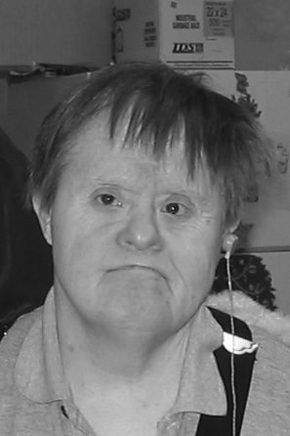
Andy worked in many areas he started in Production 2 then Production 1 moved to the Flower Shop and finally Developmental 2 until his retirement. Andy worked on numerous job contracts anything for stuffing, labeling and sealing mail outs. His favorite jobs were surprise candy bags and fillers. When Andy was not busy working he LOVED to go to the City pools for a swim. He would always come back with the biggest smile across his face, flyway hair and the reddest eyes. Andy loved coffee, food and music in that order and whenever all three could be combined Andy was the happiest.

Cosmopolitan Learning Centre 17 2015 ~ 2016 Annual Report

Welcome to Holland

I am often asked to describe the experience of raising a child with a disability – to try to help people who have not shared that unique experience to understand it, to imagine how it would feel. It's like this…

When you're going to have a baby, it's like planning a fabulous vacation trip – to Italy. You buy a bunch of guidebooks and make your wonderful plans. The Coliseum, the Michelangelo David, the gondolas in Venice. You may learn some handy phrases in Italian. It's all very exciting.

After months of eager anticipation, the day finally arrives. You pack your bags and off you go. Several hours later, the plane lands. The stewardess comes in and says, " Welcome to Holland."

"Holland?!" you say. "What do you mean, Holland?" I signed up for Italy! I'm supposed to be in Italy. All my life
I've dreamed of going to Italy.

But there's been a change in the flight plan. They've landed in Holland and there you must stay.

The important thing is that they haven't taken you to some horrible, disgusting, filthy place, full of pestilence, famine and disease. It's just a different place.

So you must go out and buy a new guidebook. And you must learn a whole new language. And you will meet a whole new group of people you would never have met.

It's just a different place. It's slower paced than Italy, less flashy than Italy. But after you've been there for a while and you catch your breath, you look around, and you begin to notice that Holland has windmills, Holland has tulips, Holland even has Rembrandts.

But everyone you know is busy coming and going from Italy, and they're all bragging about what a wonderful
time they had there. And for the rest of your life you will say, "Yes, that's where I was supposed to go. That's what
I had planned."

The pain of that will never, ever, go away, because the loss of that dream is a very significant loss.

But if you spend your life mourning the fact that you didn't get to Italy, you may never be free to enjoy the very special, the very lovely things about Holland.

Written by Emily Perl Kingsley

Cosmopolitan Learning Centre 18 2015 ~ 2016 Annual Report

