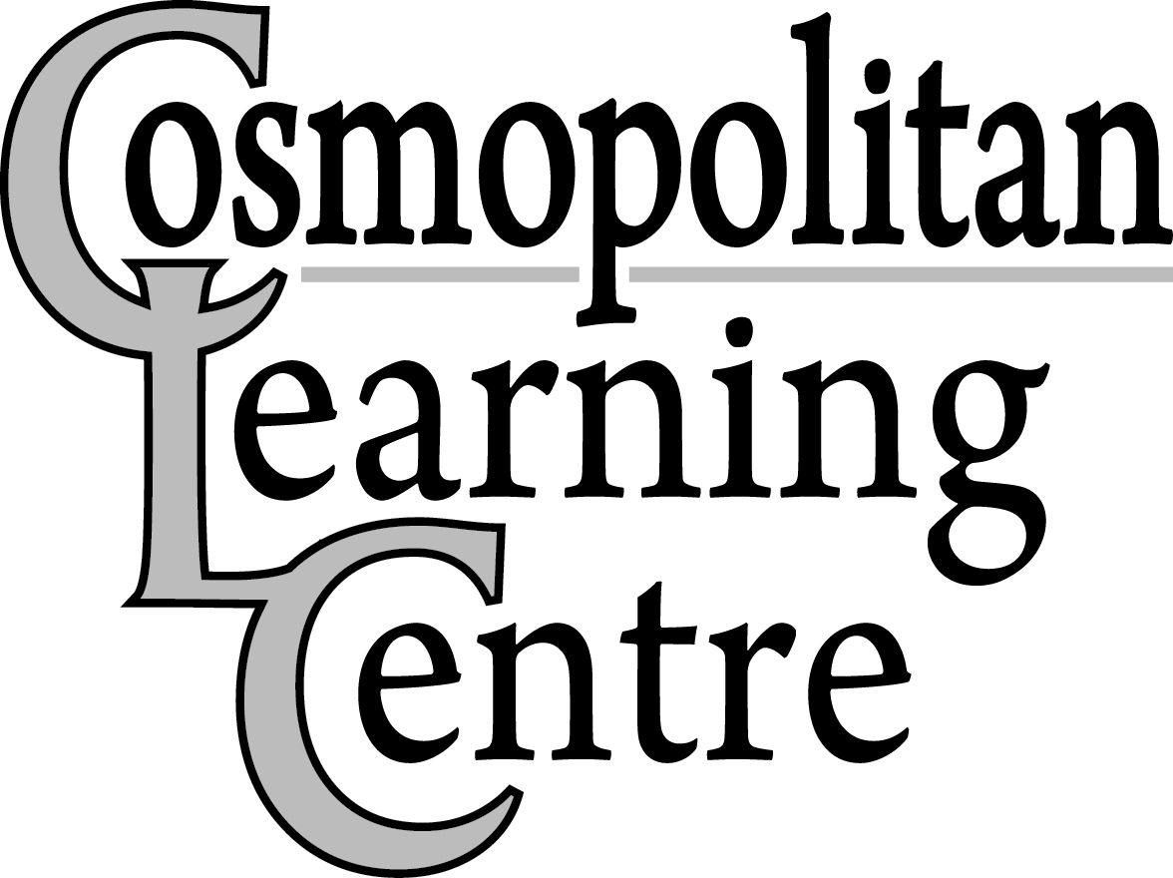
Closure Dates 2024
August 29th, 2023

Tuesday, January 2nd, 2024 – All Participants and Employees return from Winter Closure
(Employee’s Hours – Regular shift time)
Monday, February 19th, 2024 – Family Day
Friday, March 29th, 2024 – Good Friday
Monday, April 1st, 2024 – Easter Monday
Monday, May 20th, 2024 – Victoria Day

Thursday, May 30th, 2024 – Employee Professional Development Day (Employee’s Hours 8:00am-3:00pm)
(All Supported Career Initiatives Participants and All Employee’s report to work as usual)

Monday, July 1st, 2024 – Canada Day
Monday, July 22nd to Friday, August 2nd, 2024 (Inclusive) – Summer Closure

Monday, August 5th, 2024 – Saskatchewan Day

Tuesday, August 6th, 2024 – All Participants & Employees return to work from Summer Closure (Employee's Hours- Regular Shift Time)

Monday, September 2nd, 2024 – Labour Day

Thursday, September 12th, 2024 - Employee Professional Development Day (Employee’s Hours - 8:00am–3:00pm) (All locations/programs closed)
Monday, October 14th, 2024 – Thanksgiving Day

Monday, November 11th, 2024 – Remembrance Day

Thursday, November 21st, 2024 – Employee Professional Development Day (Employee’s Hours – 8:00am-3:00pm) (All Supported Career Initiatives Participants and All Employees report to work as usual)

Monday, December 23rd, 2024 – Winter Closure Begins (All locations closed)

Thursday, January 2nd, 2025 – All Participants and Employees RETURN from Winter Closure
(Employee’s Hours – Regular Shift Time)

Closure dates are available at any time on our website (www.cosmolearningcentre.ca)

