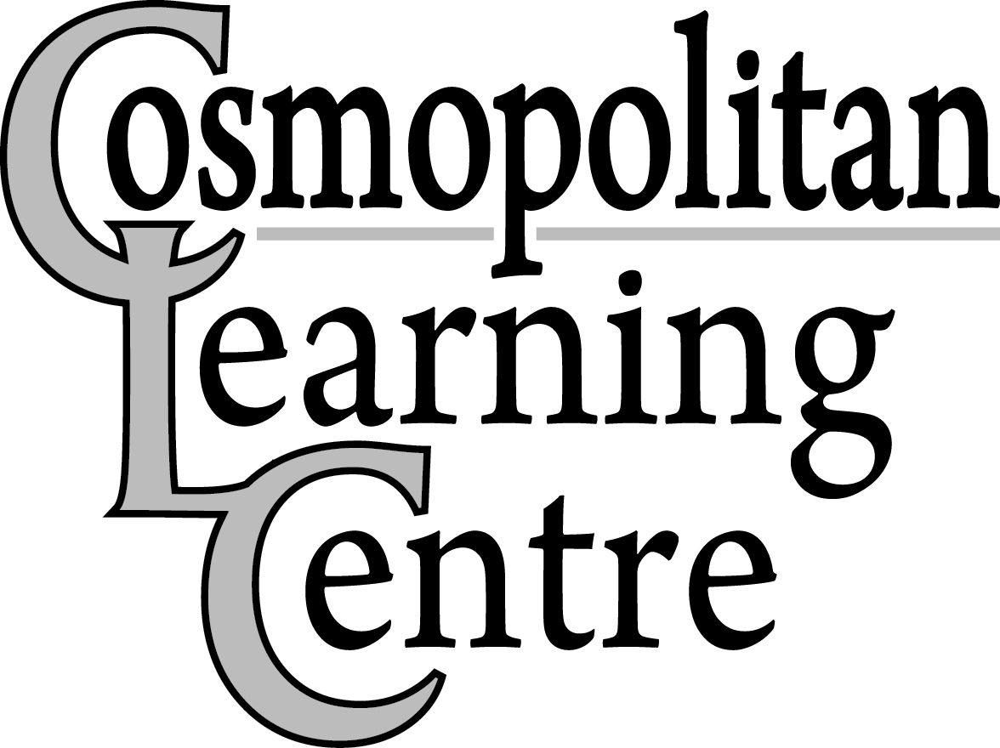 Closure Dates 2022 August 23, 2021

Tuesday, January 4th, 2022 – All Participants and Employees return from Winter Closure
(Employee’s Hours – Regular shift time)
Monday, February 21st, 2022 – Family Day
Wednesday, March 9th, 2022 – Employee Professional Development Day (Employee’s Hours 8:00am-3:00pm)
(All Supported Career Initiatives Participants and All Employee’s report to work as usual)
Friday, April 15th, 2022 – Good Friday
Monday, April 18th, 2022 – Easter Monday
Thursday, May 12th, 2022 – Employee Professional Development Day (Employee’s Hours 8:00am-3:00pm)
(All Supported Career Initiatives Participants and All Employee’s report to work as usual)

Monday, May 23rd, 2022 – Victoria Day

Friday, July 1st, 2022 – Canada Day
Friday, July 15th, 2022 – Summer Closure Begins for Learning Centre and Connections Participants
(All Supported Career Initiatives Participants and all Employees report to work as usual) (Employee’s Hours 8:00am-3:00pm)
Monday, July 18th to Friday, July 29th, 2022 (Inclusive) – Summer Closure

Monday, August 1st, 2022 – Civic Holiday

Tuesday, August 2nd, 2022 – All Participants & Employees return to work (Employee's Hours- Regular Shift Time)

Monday, September 5th, 2022 – Labour Day

Thursday, September 15th, 2022 - Employee Professional Development Day (Employee’s Hours - 8:00am–3:00pm) (All locations/programs closed)
Monday, October 10th, 2022 – Thanksgiving Day

Friday, November 11th, 2022 – Remembrance Day

Thursday, November 17th, 2022 – Employee Professional Development Day (Employee’s Hours – 8:00am-3:00pm) (All Supported Career Initiatives Participants and All Employees report to work as usual)

Wednesday, December 21st, 2022 – Employee Professional Development Day (Employee’s Hours 8:00am – 3:00pm) (All Supported Career Initiatives Participants and All Employees report to work as usual)

Thursday, December 22nd, 2022 – Winter Closure Begins (All locations closed)

December 23rd, 2022 and January 2nd, 2023 – In Lieu - Christmas Day & New Year’s Day

Tuesday, January 3rd, 2023 – All Participants and Employees RETURN from Winter Closure
(Employee’s Hours – Regular Shift Time)

Closure dates are available at any time on our website (www.cosmolearningcentre.ca)

