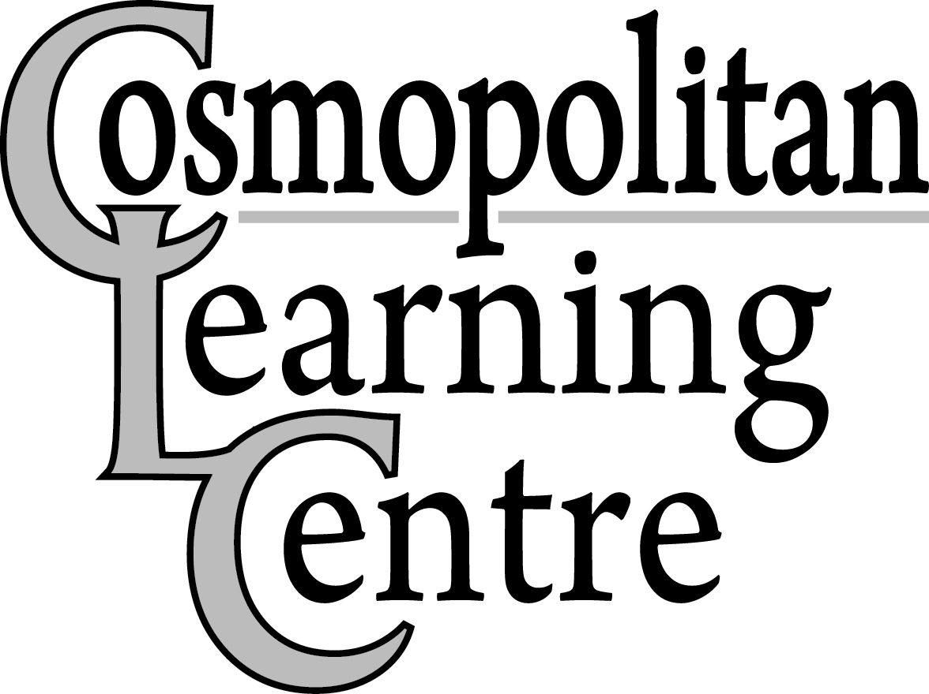 Closure Dates 2021
Revised: August 20, 2021
Monday, January 4th, 2021 – All Participants and Employees return from Winter Closure
(Employee’s Hours – Regular shift time)
Monday, February 15th, 2021 – Family Day

Wednesday, March 24th, 2021 – Employee Professional Development Day (Employee’s Hours 8:00am-3:00pm)
(All Supported Career Initiatives Participants and All Employee’s report to work as usual) CANCELLED – COSMO TO REMAIN OPEN
Friday, April 2nd, 2021 – Good Friday
Monday, April 5th, 2021 – Easter Monday
Thursday, May 13th, 2021 – Employee Professional Development Day (Employee’s Hours 8:00am-3:00pm)
(All Supported Career Initiatives Participants and All Employee’s report to work as usual) CANCELLED – COSMO TO REMAIN OPEN

Monday, May 24th, 2021 – Victoria Day

Thursday, July 1st, 2021 – Canada Day
Friday, July 16th, 2021 – Summer Closure Begins for Learning Centre and Connections Participants
(All Supported Career Initiatives Participants and all Employees report to work as usual) (Employee’s Hours 8:00am-3:00pm) CANCELLED – COSMO TO REMAIN OPEN

Monday, July 19th to Friday, July 30th, 2021 (Inclusive) – Summer Closure

Monday, August 2nd, 2021 – Civic Holiday

Tuesday, August 3rd, 2021 – All Participants & Employees return to work (Employee's Hours- Regular Shift Time)

Monday, September 6th, 2021 – Labour Day

Thursday, September 16th, 2021 - Employee Professional Development Day (Employee’s Hours - 8:00am–3:00pm) (All locations/programs closed) CANCELLED – COSMO TO REMAIN OPEN
Monday, October 11th, 2021 – Thanksgiving Day

Thursday, November 11th, 2021 – Remembrance Day

Friday, November 12th, 2021 – Employee Professional Development Day (Employee’s Hours – 8:00am-3:00pm)
(All Supported Career Initiatives Participants and All Employees report to work as usual) CANCELLED – COSMO TO REMAIN OPEN

Tuesday, November 23rd, 2021 - Employee Professional Development Day (Employee’s Hours - 8:00am–3:00pm) (All locations/programs closed) ** NEW ADDITION to closure dates**

Wednesday, December 22nd, 2021 – Employee Professional Development Day (Employee’s Hours 8:00am – 3:00pm) (All Supported Career Initiatives Participants and All Employees report to work as usual)

Thursday, December 23rd, 2021 – Winter Closure Begins (All locations closed)

December 27th, December 28th, and January 3rd, 2021 – In Lieu - Christmas Day, Boxing Day, & New Year’s Day

Tuesday, January 4th, 2022 – All Participants and Employees return from Winter Closure
(Employee’s Hours – Regular Shift Time)

Closure dates are available at any time on our website (www.cosmolearningcentre.ca)

