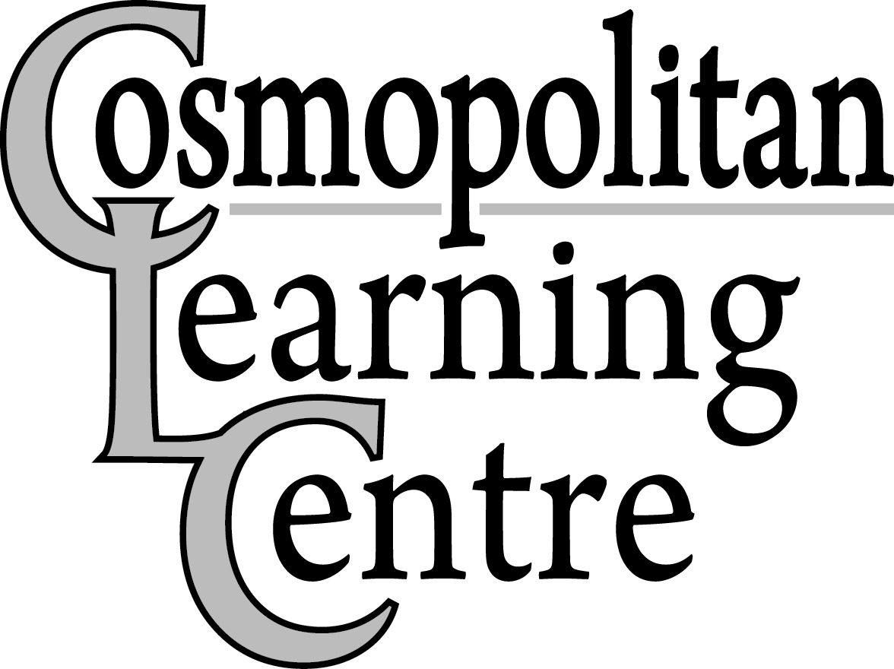 Closure Dates 2020
Revised: May 11, 2020

Thursday, January 2nd, 2020 – All Participants and Employees return from Winter Closure
(Employee’s Hours – Regular shift time)
Friday, January 31st, 2020- Employee Professional Development Day (Employee’s Hours: 8:00am-3:00pm)
(All Supported Career Initiatives Participants and All Employee’s report to work as usual)
Monday, February 17th, 2020 – Family Day
Wednesday, April 1st, 2020 – Employee Professional Development Day (Employee’s Hours 8:00am-3:00pm)
(All Supported Career Initiatives Participants and All Employee’s report to work as usual)
Friday, April 10th, 2020 – Good Friday
Monday, April 13th, 2020 – Easter Monday
Monday, May 18th, 2020 – Victoria Day
Thursday, June 4th, 2020 – Employee Professional Development Day (Employee’s Hours 8:00am-3:00pm)
(All Supported Career Initiatives Participants and All Employee’s report to work as usual)

Wednesday, July 1st, 2020 – Canada Day
Friday, July 17th, 2020 – Summer Closure Begins for Learning Centre and Connections Participants
(All Supported Career Initiatives Participants and all Employees report to work as usual)
(Employee’s Hours 8:00am-3:00pm) - CANCELLED (COSMO TO REMAIN OPEN)

Monday, July 20th, 2020 to Friday, July 31st, 2020 (Inclusive) – Summer Closure - CANCELLED (COSMO TO REMAIN OPEN)

Monday, August 3rd, 2020 – Civic Holiday

Monday, September 7th, 2020 – Labour Day

Thursday, September 17th, 2020 - Employee Professional Development Day (Employee’s Hours - 8:00am–3:00pm) (All Supported Career Initiatives Participants and All Employees report to work as usual)
Monday, October 12th, 2020 – Thanksgiving Day

Friday, November 6th, 2020 – Employee Professional Development Day (Employee’s Hours – 8:00am-3:00pm)
(All locations/programs closed)

Wednesday, November 11th, 2020 – Remembrance Day

Tuesday, December 22nd, 2020 – Employee Professional Development Day (Employee’s Hours 8:00am – 3:00pm)
(All Supported Career Initiatives Participants and All Employees report to work as usual)

Wednesday, December 23rd, 2020 – Winter Closure Begins (All locations closed)

December 25th, December 28th, and January 1st, 2020 – Christmas Day, Boxing Day, & New Year’s Day

Monday, January 4th, 2021 – All Participants and Employees return from Winter Closure
(Employee’s Hours – Regular Shift Time)

Closure dates are available at any time on our website (www.cosmolearningcentre.ca)

